Insert School Logo

Semester Two

Examination 2020

Question/Answer booklet

MATHEMATICS
METHODS UNIT 1 and 2

Section Two:
Calculator–assumed

Student Name: _____________________________________

Teacher’s Name: _____________________________________

Time allowed for this section
Reading time before commencing work: ten minutes
Working time for paper: one hundred minutes

Material required/recommended for this section

To be provided by the supervisor
This Question/Answer booklet
Formula Sheet (retained from Section One)

To be provided by the candidate
Standard items: pens (blue/black preferred), pencils (including coloured), sharpener, correction tape/fluid, erasers, ruler, highlighters

Special Items: drawing instruments, templates, notes on two unfolded sheets of A4 paper, and up to three calculators approved for use in the WACE examinations.

Important note to candidates
No other items may be taken into the examination room. It is your responsibility to ensure that you do not have any unauthorised notes or other items of a non–personal nature in the examination room. If you have any unauthorised material with you, hand it to the supervisor before reading any further.

Structure of this paper

 | Number of questions available | Number of questions to be attempted | Working time (minutes) | Marks available | Percentage of exam
Section One  Calculator—free | 7 | 7 | 50 | 50 | 35
Section Two  Calculator—assumed | 13 | 13 | 100 | 100 | 65
 |  |  |  | 150 | 100

Instructions to candidates

- The rules for the conduct of Western Australian external examinations are detailed in the
Year 12 Information Handbook 2020. Sitting this examination implies that you agree to abide by these rules.

- Answer the questions according to the following instructions.

Show all your working clearly. Your working should be in sufficient detail to allow your
answers to be checked readily and for marks to be awarded for reasoning. Incorrect answers given without supporting reasoning cannot be allocated any marks. For any question or part question worth more than two marks, valid working or justification is required to receive full marks. If you repeat an answer to any question, ensure that you cancel the answer you do not wish to have marked.

It is recommended that you do not use pencil, except in diagrams.

- You must be careful to confine your responses to the specific questions asked and to follow any instructions that are specific to a particular question.

- Spare pages are included at the end of this booklet. They can be used for planning your responses and/or as additional space if required to continue an answer.
- Planning: If you use the spare pages for planning, indicate this clearly at the top of the page.
- Continuing an answer: If you need to use the space to continue an answer, indicate in the original answer space where the answer is continued, i.e. give the page number. Fill in the number of the question that you are continuing to answer at the top of the page.

- The Formula Sheet is not handed in with your Question/Answer Booklet.

Section Two: Calculator–assumed 65% (100 marks)

This section has thirteen (13) questions. Attempt all questions. Write your answers in the spaces provided.

Spare pages are included at the end of this booklet. They can be used for planning your responses and/or as additional space if required to continue an answer.

- Planning: If you use the spare pages for planning, indicate this clearly at the top of the page.
- Continuing an answer: If you need to use the space to continue an answer, indicate in the original answer space where the answer is continued, i.e. give the page number. Fill in the number of the question(s) that you are continuing to answer at the top of the page.

Working time: 100 minutes

Question 8 (6 marks)

A water tank initially holds 3600 litres of water. The water drains from the bottom of the tank. A mathematical model that predicts the volume, V litres, of water that will remain in the tank after t minutes is given by:
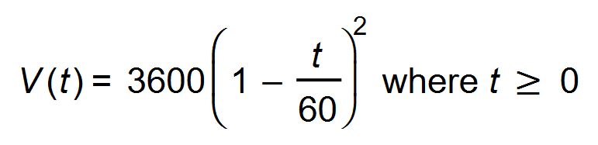
(a) What volume does the model predict will remain after 10 minutes? (1 mark)

(b) How long does it take for the tank to drain? (1 mark)

(c) At what rate does the model predict that the water will drain from the tank after twenty minutes? (2 marks)

(d) Show that the volume of water remaining in a tank holding double the volume of water initially will drain at double the rate. (2 marks)

Question 9 (10 marks)

Indy accepts employment with an initial annual salary of $52 000. In each of the following years her annual salary is increased by $2575 per year.

Skye accepts employment with an initial salary of $52 000. In each of the following years her annual salary is increased by 4%.

(a) State the recursive formula for Indy’s annual salary. (2 marks)

(b) State the general (explicit) formula for Skye’s annual salary during the n^{th} year. (2 marks)

(c) Determine Skye’s annual salary during the 10th year. (1 mark)

(d) During which year does Skye earn more than Indy for the first time? (2 marks)

(e) By what amount does the total amount earned by Skye exceed that earned
by Indy at the end of the twentieth year? (3 marks)

Question 10 (6 marks)

A cylinder, of radius x metres and height 2h metres, is to be inscribed in a sphere
of constant radius R (m) centred at O as shown below.
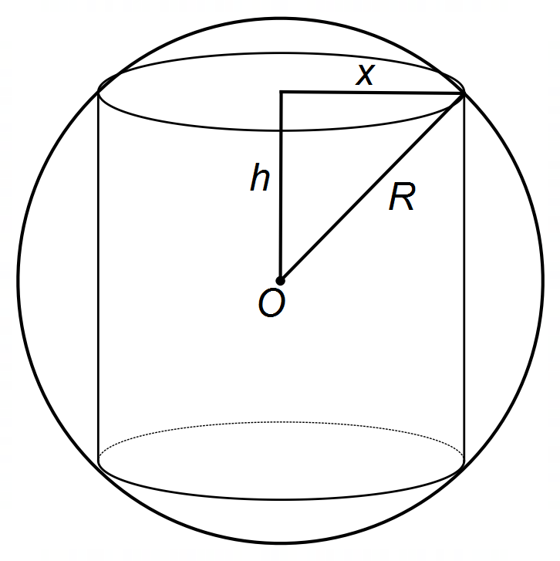

(a) Show that the volume of the cylinder is given by 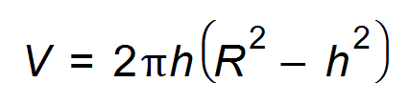. (3 marks)

(b) Use Calculus techniques to show that the cylinder has a maximum volume
when 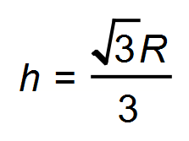. (3 marks)

Question 11 (6 marks)

Consider a sequence: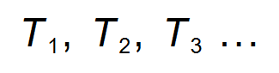 Every term in the sequence after the first term, is equal to one less than the sum of the term immediately before and after it. A sequence has the first term T₁ = x and the third term T₃ = y.

(a) Show that T₂ =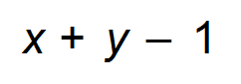. (1 mark)

(b) Determine the sum of the first four terms in terms of x and y. (3 marks)

(c) Explain why the sequence is neither Arithmetic nor Geometric. (2 marks)

Question 12 (5 marks)

Consider the function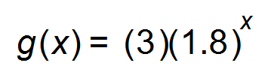.
Determine whether each statement is true or false. (5 marks)

(a) The graph has a y-intercept of 1.8. __________

(b) As x increases, y tends to 0. __________

(c) The function is decreasing at a rate of 20%. __________

(d) The graph has an asymptote at y = 0 __________

(e) As x decreases, y approaches infinity. __________

Question 13 (7 marks)

Alice has some Mathematics activities to complete.
(a) She attempts to differentiate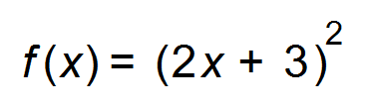. She has written the first line as follows: 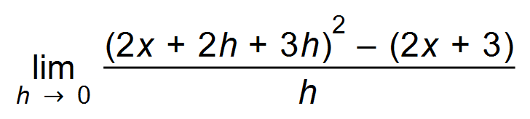. Re-write her first line correctly. (2 marks)

(b) By evaluating the limit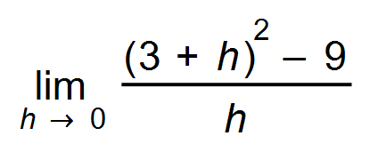 Alice correctly calculates the instantaneous rate of change to be equal to 6. How did she get this value?
(2 marks)

(c) Alice is asked to demonstrate to her class how to determine the value of y on the graph of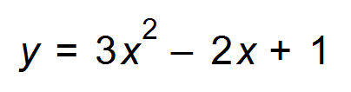where the gradient is 4. Show how she could correctly find this value.
(2 marks)

(d) Her final task is to find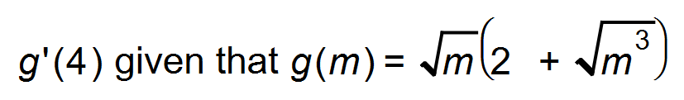. Determine this exact value for her. (1 mark)

Question 14 (4 marks)

Match each function to its graph below. (4 marks)

(a) 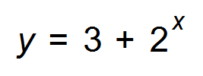 __________ (b) 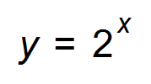 __________

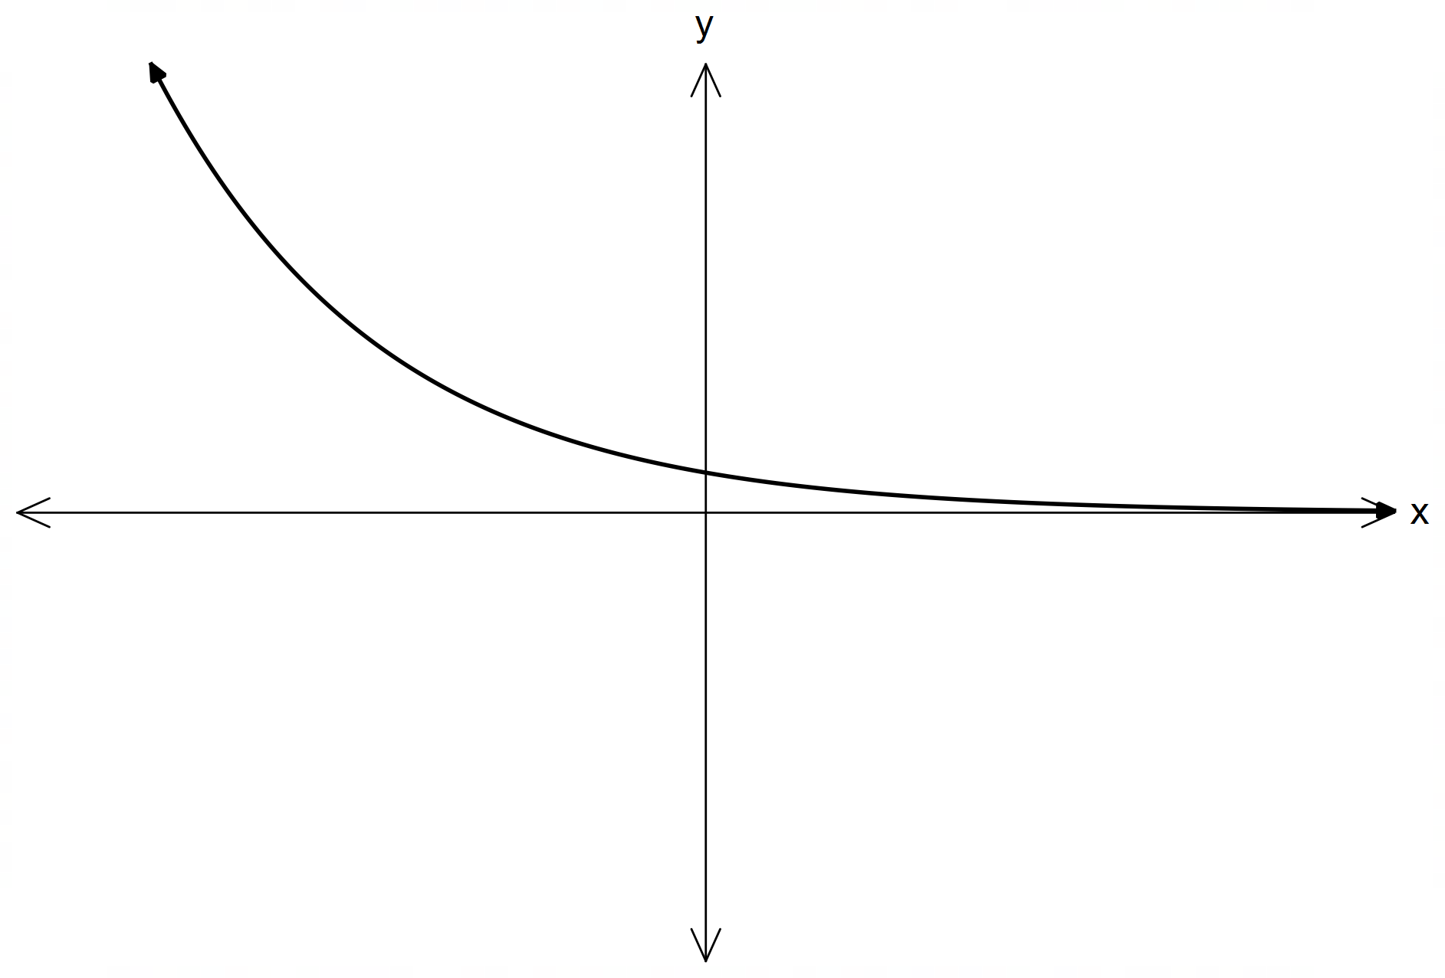(c) 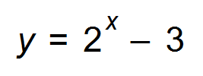 __________ (d) 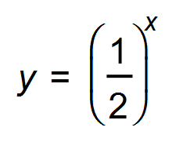 __________
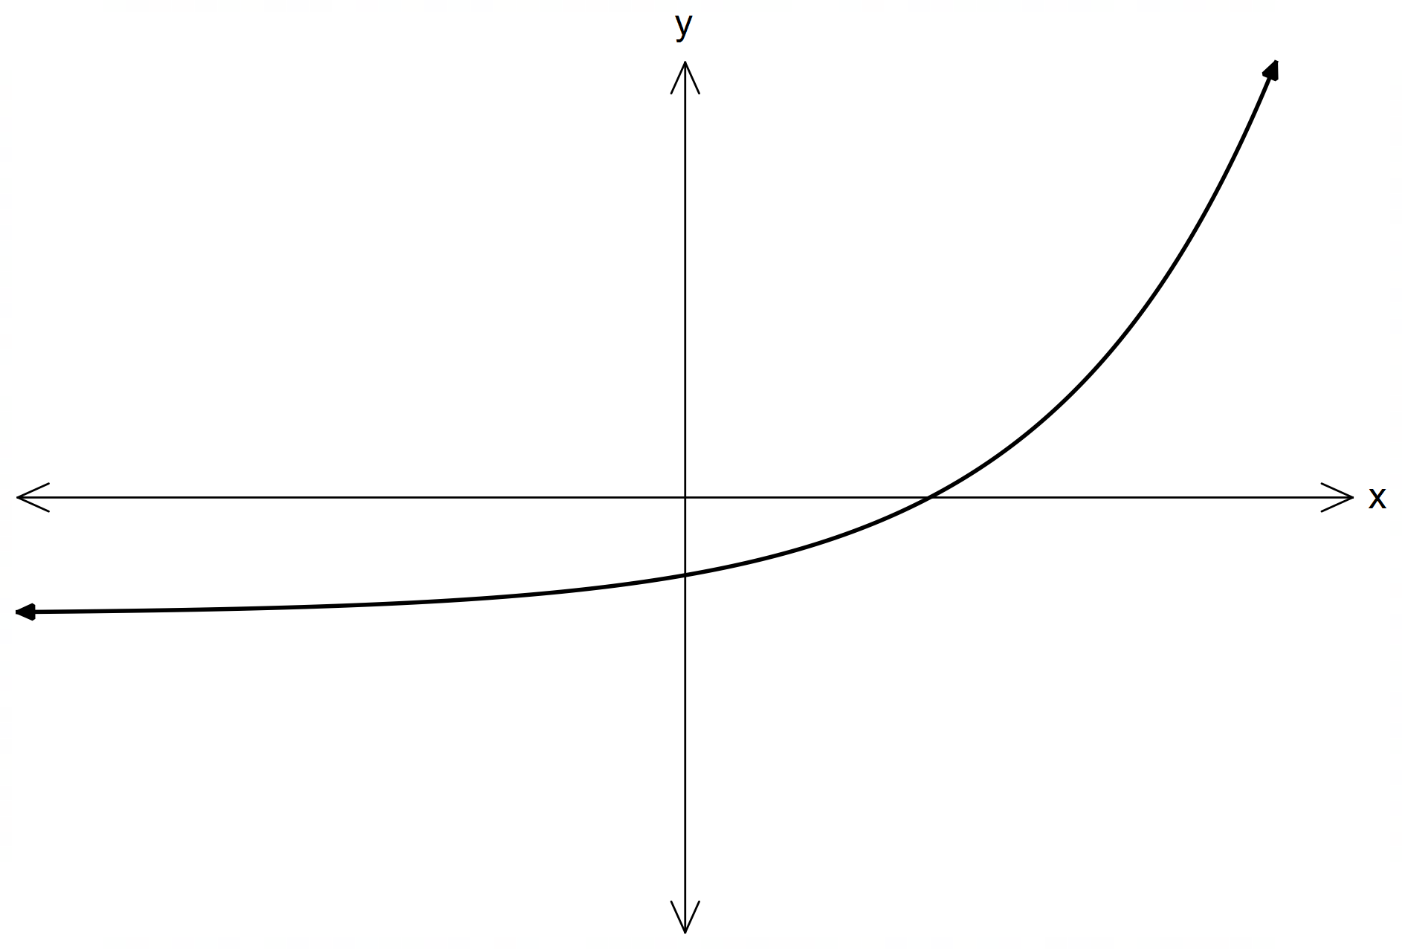A B

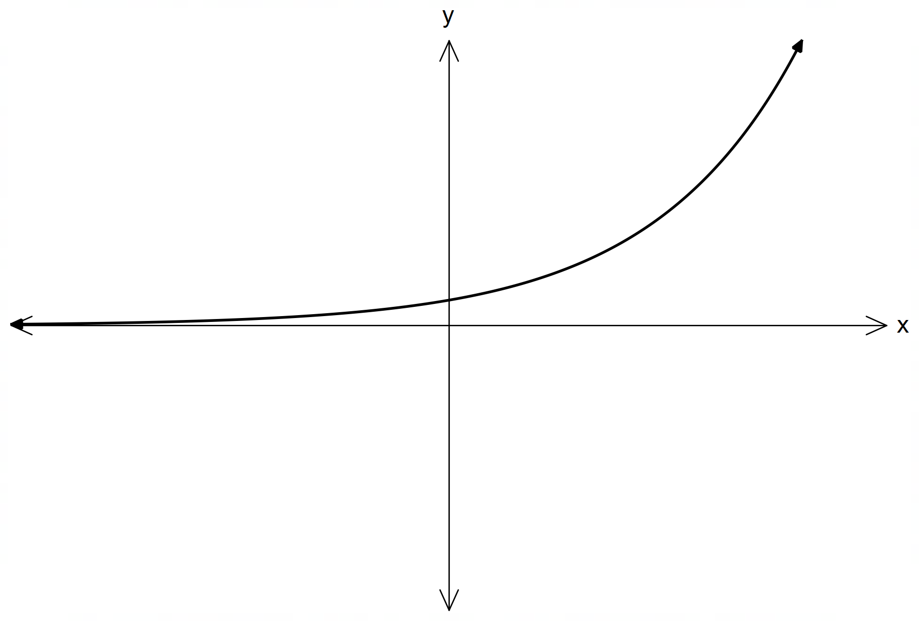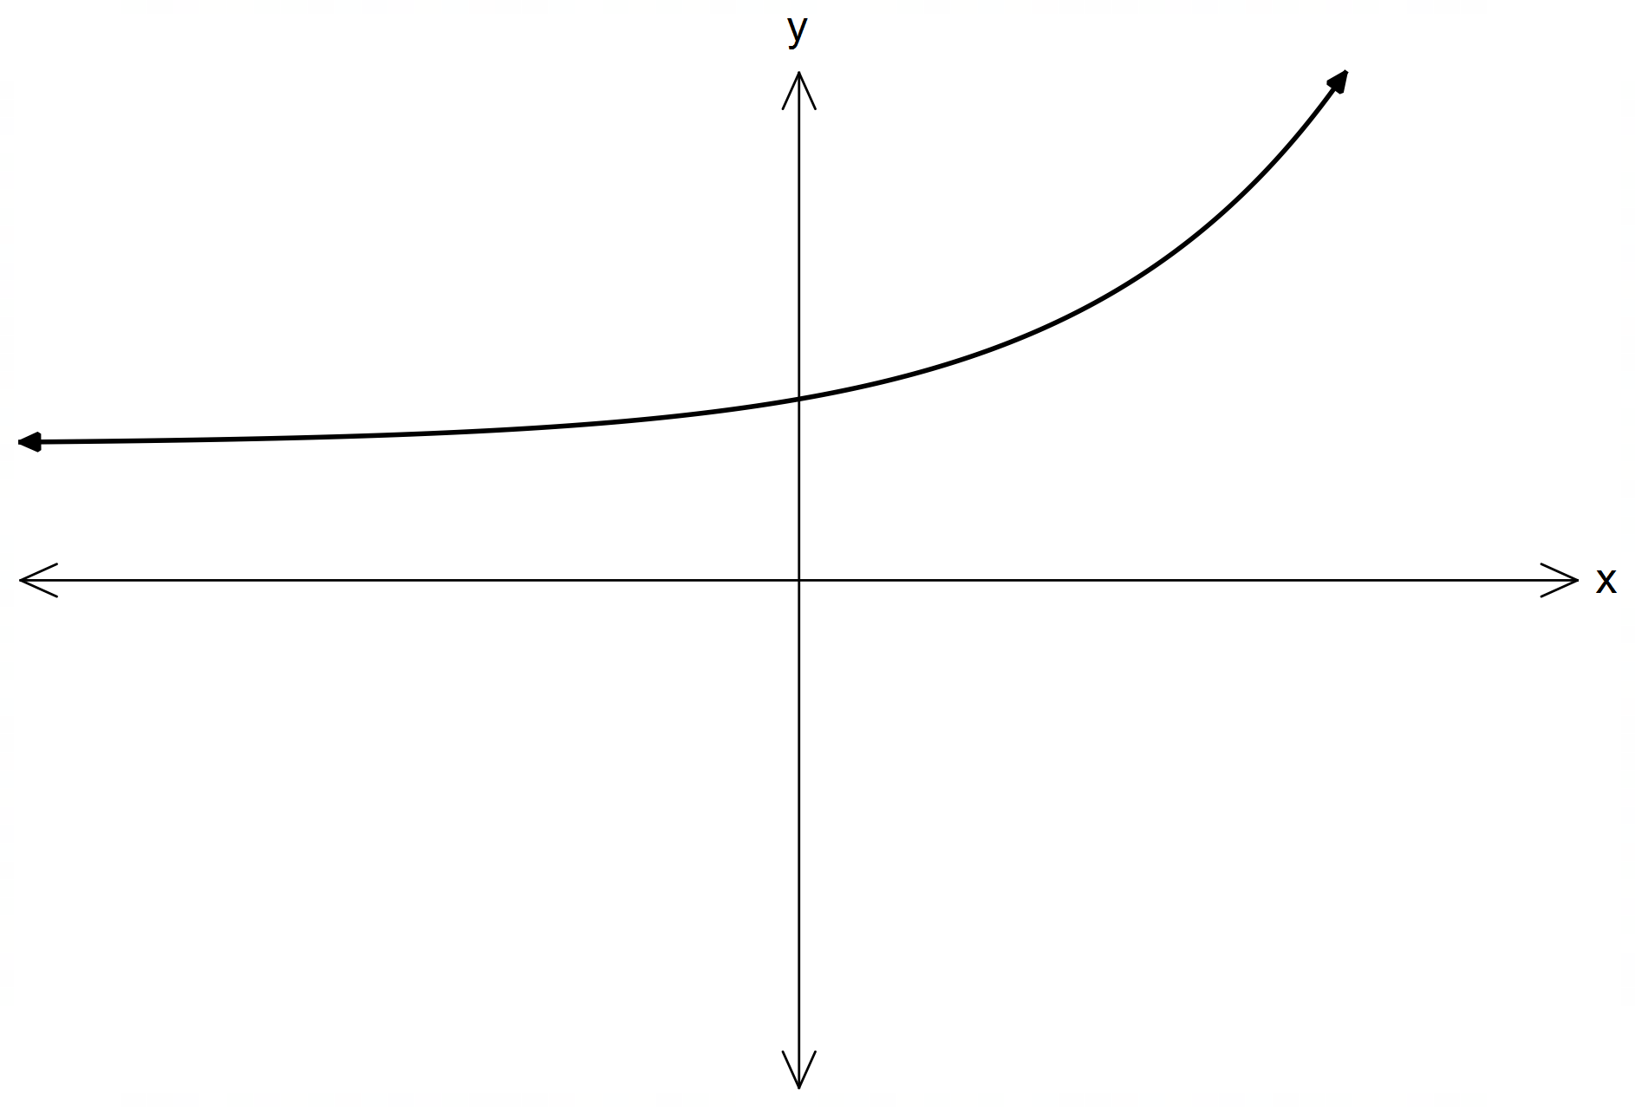C D

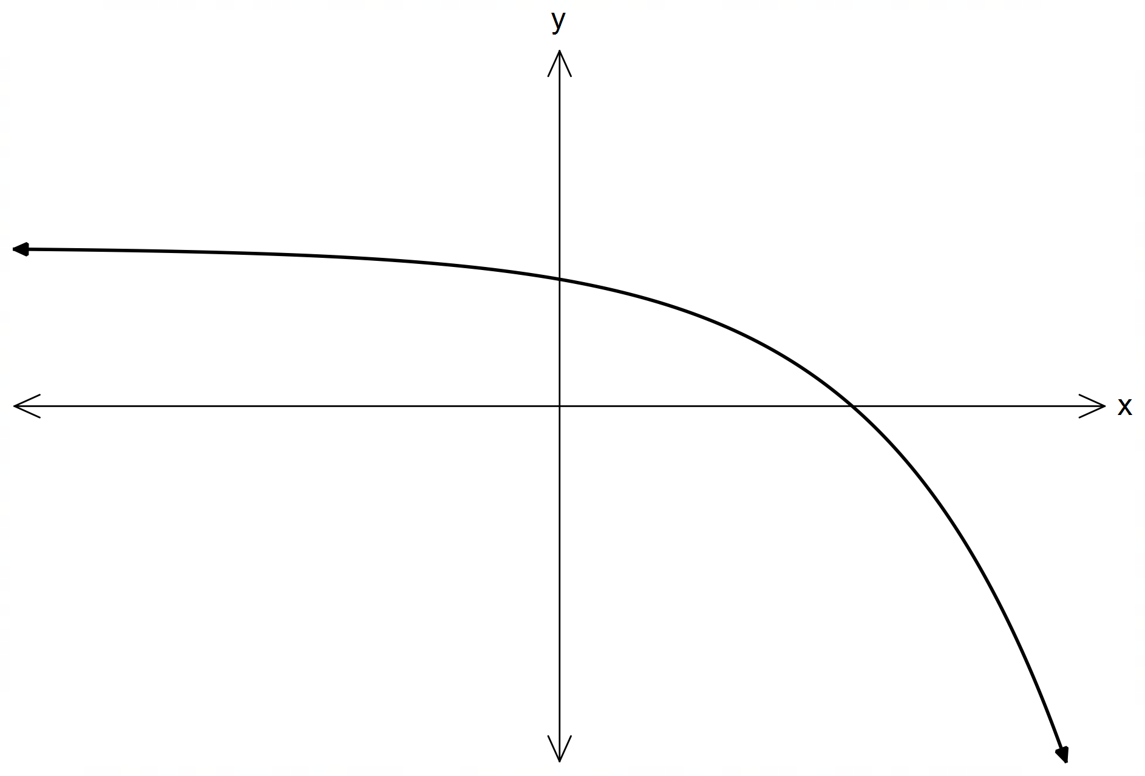

E

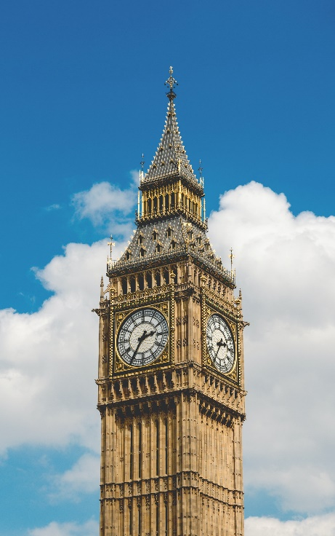
Question 15 (5 marks)

The Big Ben clock in London has an hour hand that is 2.7 m long.

(a) If the length of the arc through which the hour hand turns is 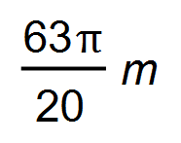, how many hours has this taken? (3 marks)

(b) Determine the exact area through which the hand would pass in 2 hours. (2 marks)

Question 16 (12 marks)
The displacement of a particle moving in rectilinear motion is modelled by 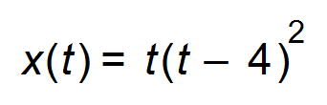 where t is the time in seconds and x is the displacement in metres.

(a) Determine the initial displacement of the particle. (1 mark)

(b) Calculate the initial velocity of the particle and hence comment on the initial
direction of motion of the particle. (3 marks)

(c) Determine when the particle first changes direction. (1 mark)

(d) Find the acceleration of the particle after 3 seconds. (2 marks)

(e) At t = 3 seconds, is the particle increasing or decreasing speed? Explain your answer.
(2 marks)

(f) Determine the total distance covered by the particle during the first 5 seconds. (3 marks)

Question 17 (6 marks)

Scientists in a medical research laboratory wanted to test the power of a new anti-biotic to destroy a certain bacteria which was doubling every 12 hours.

(a) Show that the rate of growth of the number of bacteria was 5.95% per hour. (1 mark)

(b) If the scientists had a culture of 1000 bacteria, how long would it take for this bacterial population to grow to a colony of 9000 bacteria? (2 marks)

(c) The scientists hope that the anti-biotic will kill a third of the bacteria every hour. They add the anti-biotic to the colony of 9000 bacteria. A little over 8 hours after the experiment begins, the scientists find one lonely bacterium has survived the onslaught.
Were the scientists’ expectations accurate? Justify your answer mathematically.
(3 marks)

Question 18 (14 marks)

(a) If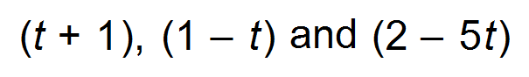 are the first three terms of an infinite,
converging geometric sequence, determine:

(i) the value(s) of t and the common ratio. (4 marks)

(ii) the sum to infinity. (2 marks)

(Question 18 continued)

(b) In an Arithmetic Series consisting of 15 terms, it is given that 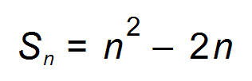.
Determine

(i) the sum of the first 8 terms. (1 mark)

(ii) the eighth term. (2 marks)

(iii) the sum of the last three terms. (2 marks)

(c) The k-th term of an arithmetic progression is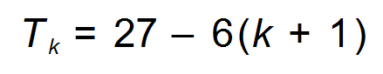.
Determine the sum of the first twenty terms. (3 marks)

Question 19 (9 marks)

Consider the function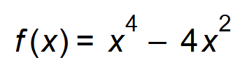.
(a) State the coordinates of the x - intercepts of the function. (1 mark)

(b) Use Calculus methods to determine the exact coordinates and nature of any stationary points. (5 marks)

(c) Sketch the graph ofover the domain 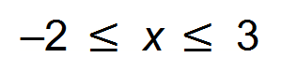. (3 marks)
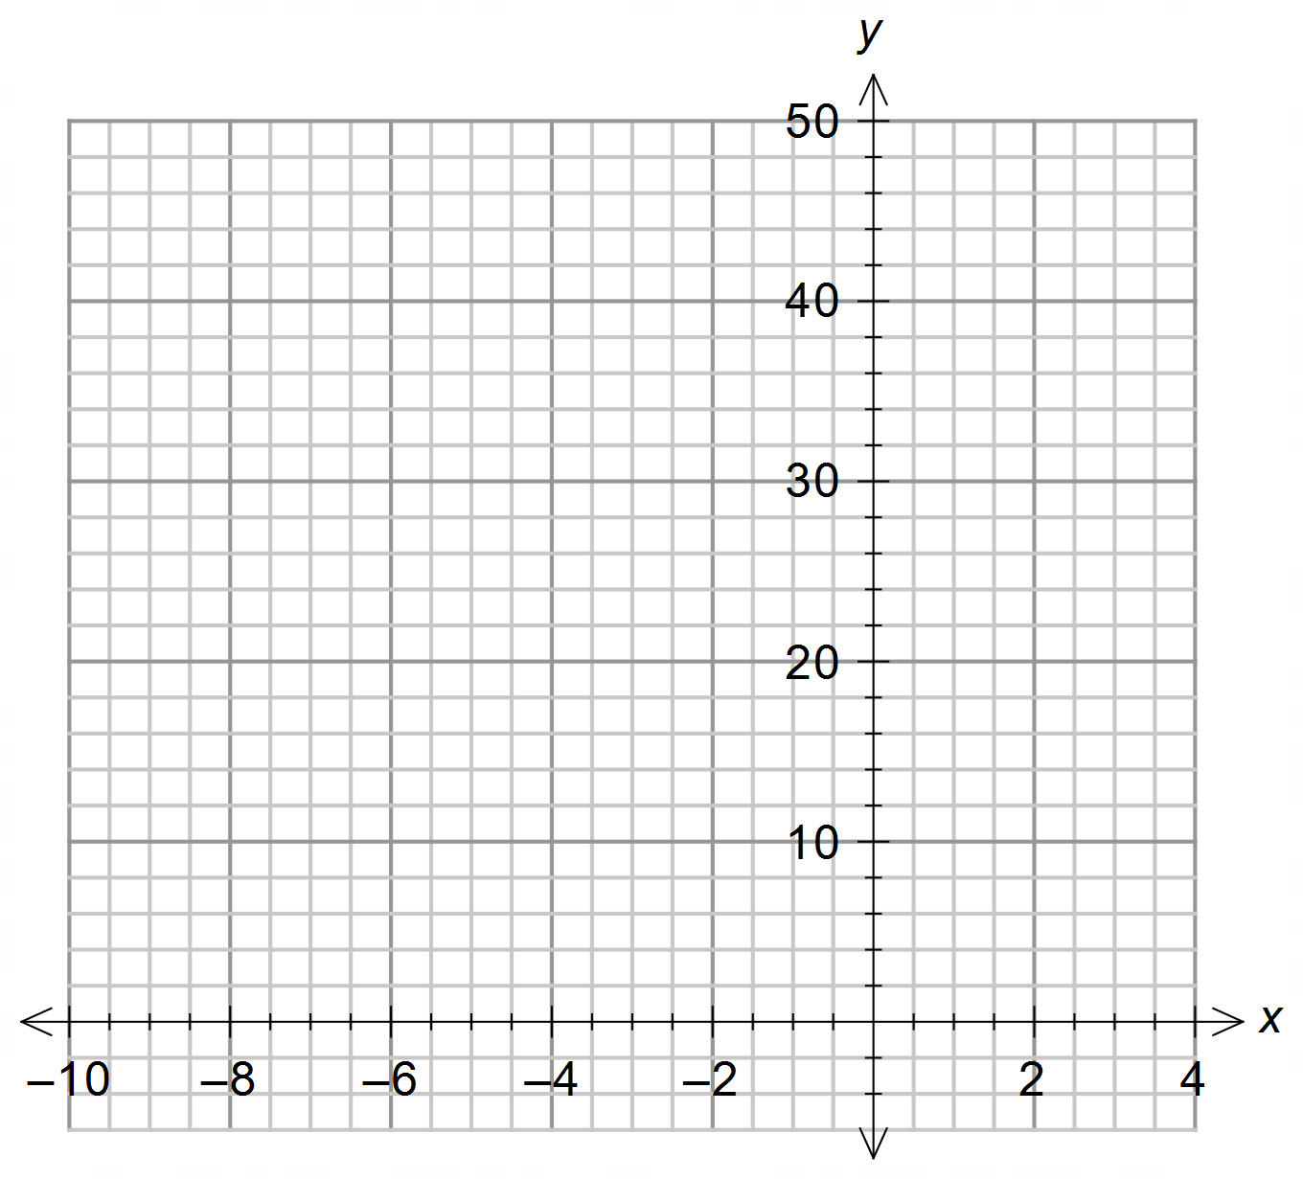

Question 20 (10 marks)

(a) Determine the coordinates on the graph of 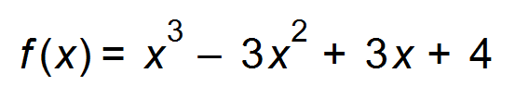 where the tangent

(i) has a gradient of 12. (2 marks)

(ii) is parallel to the line 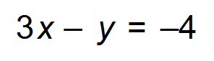. (2 marks)

(iii) is perpendicular to the line 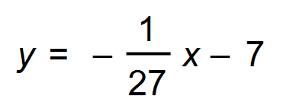. (2 marks)

(b) The gradient function of a curve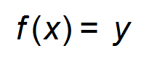is given by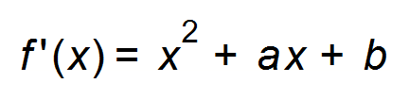.
The curve has turning points at 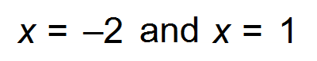. Find the equation of the curve if it passes through the point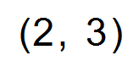. (4 marks)

End of Questions
Additional working space

Question number(s): ……………………

Additional working space

Question number(s): ……………………

